Mind View User’s Guide

Mind View – Table of Contents

Topic | See Page
Installing for Windows | 1-1
Basic Viewer | 2-1
Landmarking | 3-1
Point Process | 4-1
Neighborhood Process | 5-1
Combination Process | 6-1
Interpolation Operations | 7-1
Masks | 8-1
Volume Picker | 9-1
Surface Area | 10-1
Surface Area using Cycloids | 11-1
Cell Counter | 12-1
1-1

Installing for Windows

Overview

Introduction | This section describes the procedure to install Mind View on your computer.

Prerequisites | In order to run Mind View, you must be running a Windows OS, and Matlab 7.

In this chapter | This chapter has one section.

Topic | See Page
Installation Procedure | 1-2

1-2

Installation Procedure

Procedure | Follow these directions to install.

Step | Action
1 | Go to \local\win\blox and copy the alpha_mat directory to your disk.
2 | Go to Control Panel → System → Advanced → Environment Variables and then click on PATH. Append the PATH with the following “;LOCATION_OF_ALPHA_MAT\blox_mat\win32” where LOCATION_OF_ALPHA_MAT is the location of the alpha_mat folder.
3 | Go to C:\MATLAB7\toolbox\local and open the librarypath.txt file. Add the following line to it “LOCATION_OF_ALPHA_MAT/blox_mat/$arch” where LOCATION_OF_ALPHA_MAT is the location of the alpha_mat folder.
4 | Go to C:\MATLAB7\bin\win32 and open the java.opts file with a text editor. If this file does not exist here, then create it. Delete what may be in there and add the following two lines.  -Xmx600m  -Xms600m  Then save and close the file.

2-1

Basic Viewer

Overview

Introduction | This section will describe the functionality of the basic Graphical User Interface (GUI). It will include information on opening and closing a dataset, as well as using all of the functions associated with the basic GUI.

Prerequisites | This chapter assumes that you already have Mind View successfully installed on your machine.

In this chapter | This chapter is divided into twelve sections.

Topic | See Page
Starting and exiting the GUI | 2-2
Opening a dataset | 2-3
Closing a dataset | 2-5
Changing the contrast | 2-6
Moving around the dataset | 2-7
Finding the current location with crosshairs | 2-10
Zooming onto the data | 2-11
Showing isocontours | 2-12
Toggling position and 3D information | 2-13
Opening a 2D manifold | 2-14
Navigating around the 3D view | 2-16
Changing the appearance of 2D manifolds | 2-17

2-2

Starting and Exiting the GUI

Introduction | This section will describe the procedure for invoking the GUI and closing it.

Starting the GUI | In order to invoke the base GUI, simply type “orthogonal” from the command prompt in Matlab. (Note: Do not include the quotation marks). This will bring up the following window:  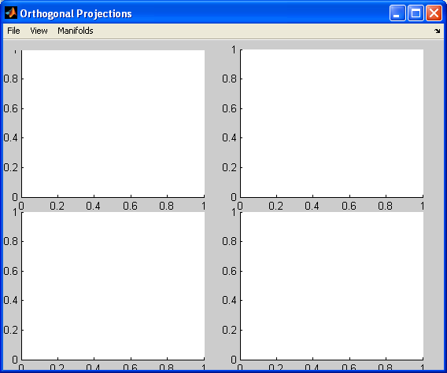

Exiting the GUI | There are two ways to exit the GUI. The first is to select File → Exit. The second way is to click the red X in the top right corner of the window.

2-3

Opening a dataset

Introduction | This section gives instructions on opening a dataset that is saved on your hard disk.

Procedure | Follow this procedure for opening a dataset.

Step | Action
1 | Invoke the base GUI as described above.
2 | Go to File → Open Volume and the following dialog box will pop up:  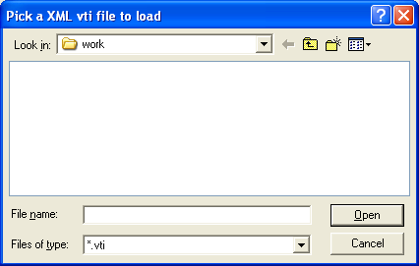
3 | Navigate to the location of the dataset that has been saved on your disk and click Open.
4 | Now the main window should have data contained in it and look like the following (Note: This screen shot was taken from the short data contained on the website):  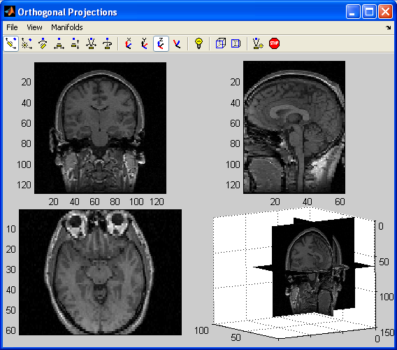

Continued on next page
2-4

Opening a dataset, Continued

Multiple datasets | More than one dataset can be opened at a time. Follow the exact same procedure for opening the first dataset to open more than one dataset.

Procedure | Follow this procedure to toggle between multiple open datasets.

Step | Action
1 | Open as many datasets as are desired by following the above procedure as many times as needed.
2 | Go to the View menu which will now have all of the open data sets names appended to the end of it with the checked one being the one currently in the viewer.
3 | Click on a different dataset’s name to switch the view to that dataset.

Using the command line | A dataset that already exists in the base workspace can be read in directly. In order to do this simply type “orthogonal(<name of data>)” where <name of data> is replaced by the name of the dataset in the base workspace. This applies to all modules, not just orthogonal. In order to use this with another module, just type that module’s name instead of orthogonal, and the syntax is that same.

2-5

Closing a dataset

Introduction | This section describes how to close a dataset.

Action | Go to File → Close Volume. After clicking it, the following should appear :  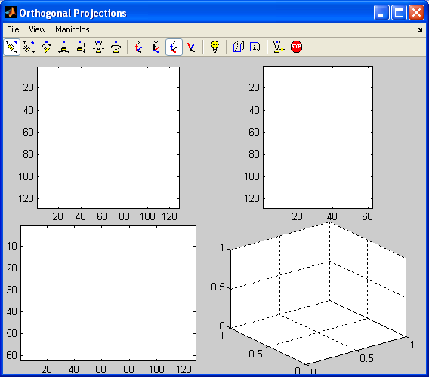

Note | If more than one dataset is open, following the above action will close the currently open dataset and switch the view to that of another open dataset.

2-6

Changing the contrast

Introduction | This section will show you how to change the contrast for an open dataset.

Procedure | Follow these steps to change the contrast.

Step | Action
1 | Go to View → Set Contrast
2 | The following dialog box should appear:  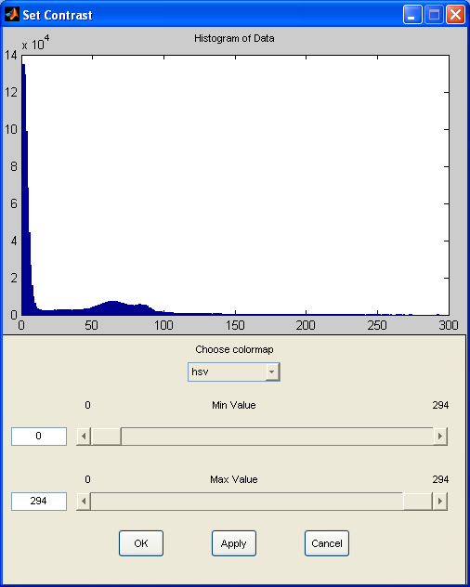
3 | The top part of the window is a histogram of the open dataset. This contains only information and is not editable.
4 | Use the drop-down menu labeled “Choose colormap” to set the colormap to one of Matlab’s predefined choices.
5 | Use the top slider to set the min value of the colormap. All values below the min are set to the given colormap’s lowest color.
6 | Use the bottom slider to set the max value of the colormap. All the values above the max are set to the given colormap’s highest color.
7 | Click Apply to preview your choice, and OK to accept it.

2-7

Moving around the dataset

Introduction | This defines the different windows in the viewer and the three ways to move around the dataset.

Windows | The GUI is composed of four windows. Below is a picture of the base GUI with data loaded:  The top left window is the coronal view, the top right is the sagittal view, the bottom left is the axial view, and the bottom right is the 3D view. Above the four windows is the camera toolbar. Mouse over any of the icons to get a description of what that does.

Continued on next page
2-8

Moving around the dataset, Continued

Procedure | Follow this procedure to set the center coordinates of the data.

Step | Action
1 | Go to View → Set Center Coordinates. You should get the following dialog box:  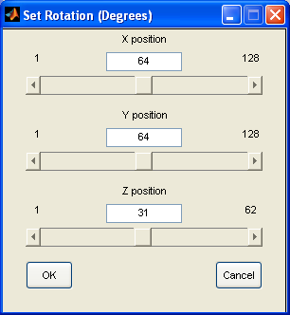
2 | Use the sliders or enter a voxel number into the text boxes to change the center coordinates of the windows.
3 | Click OK and the new center coordinates will be displayed on the four windows.

Procedure | Follow this procedure to step one value in a direction.

Step | Action
1 | Go to View → Step Coordinates.
2 | From the submenu that appears, select the direction that you wish to move in.
3 | Notice that there are keyboard shortcuts next to each of these commands that perform the same action as the menu items.

Note | Labeled next to these commands are shortcut key combinations that perform the same actions.

Continued on next page
2-9

Moving around the dataset, Continued

Procedure | Follow this procedure to move around using the mouse.

Step | Action
1 | Go to View → Go To.
2 | Once selected, there will be a check mark next to Go To under the view menu. This signifies that the mouse is now in Go To mode.
3 | Click on any point in the three orthogonal views (the coronal, sagittal, or axial views), and that point will now become the center of the dataset.
4 | To stop being in Go To mode go to View → Go To and click again. The check mark will disappear next to Go To, and the mouse will no longer be in Go To mode.

Procedure | Follow this procedure to set the current time point.

Step | Action
1 | Go to View → Set Time Point.
2 | The following dialog box will appear.  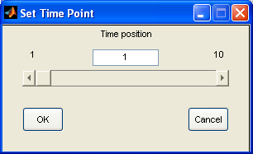  Where the number on the left is the minimum time point and on the right, then maximum.
3 | Set the time position that is desired and click OK.

Procedure | Follow this procedure to step in time.

Step | Action
1 | Go to View → Step Time Point.
2 | Click on either Next or Previous as desired.
3 | Notice that there are keyboard shortcuts next to each of these commands that perform the same action as the menu items.

2-10

Finding the current location with crosshairs

Introduction | This section describes turning the cross hairs on and off, changing their color and using them to establish location.

Procedure | How to toggle the cross hairs on and off.

Step | Action
1 | Go to View → Cross Hairs.
2 | Select On to make the cross hairs the entire length and width of the window, Short to make them some portion of the window, or Off to turn them off.

Procedure | How to change the color of the cross hairs.

Step | Action
1 | Go to View → Cross Hairs → Select Color.
2 | The following dialog box will appear:  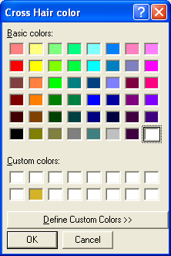  Select a color from the list that is desired or click on Define Custom Color to define a different color.
3 | Click Ok to close this window. If cross hairs are already drawn on the screen they will change to this color, if they have not been drawn yet, then when drawn they will be this color.

Usage | Cross hairs are used to show the location of the current data center. When the center coordinates are moved, the cross hairs will not lie at the center of all three windows.

2-11

Zooming onto the data

Introduction | This section describes how to zoom into specific parts of the data.

Procedure | Follow these steps to zoom in and out.

Step | Action
1 | Click on View → Zoom.
2 | The mouse will change to a picture of a magnifying glass with a plus sign in it.
3 | Click on any of the views and the location clicked will zoom in. Double click to zoom out.
4 | Select View → Zoom again to turn off zooming.

Note | Zooming is not preserved under other actions. For example, if you zoom then move to a different location in the dataset, the windows will not stay zoomed.

2-12

Showing isocontours

Introduction | This section will describe how to turn on and off isocontours for a specific value.

Procedure | How to turn on isocontours.

Step | Action
1 | Open up a dataset and go to View → Show Isocontours.
2 | The following dialog box should appear:  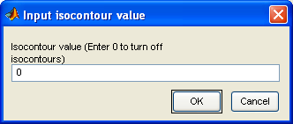
3 | Enter the value that you would like to show the isocontours at and click OK.
4 | This box will close and the isocontours will be shown on the figure. Note: isocontours only work for the three 2D views, not the 3D view.

Procedure | How to turn off isocontours.

Step | Action
1 | Go to View → Show Isocontours, and make the same dialog box appear.
2 | Enter a value of 0 and then click Ok.
3 | This box will close and no isocontours will be displayed.

2-13

Toggling position and 3D information

Introduction | This section overviews the textual information display about the volume data, and how to toggle that and the 3D projection on and off.

Volume information location | Information about the current position of the mouse is displayed above the coronal view.

Analysis of volume location | The information that appears there is in the following format, value @(x, y, z)world units x, y, z, time, channel voxels. This states the current value of the voxel the mouse is over, its coordinates in world units and its coordinates in voxel units.

Toggling volume location | Go to View → Show Position. When clicked, the check mark next to it will disappear, and the volume location will no longer be displayed. Click this menu item again to turn it back on.

Toggling 3D view | Go to View → 3D View. When clicked, the check mark next to it will disappear, and the 3D axes will go blank. Click this menu item again to turn it back on.

Reason for turning off 3D view | Some processes run faster when the computer does not have to update this display all the time.

2-14

Opening a 2D manifold

Introduction | This section gives information on how to open a 2D manifold.

Procedure | Follow these steps to open a manifold.

Step | Action
1 | Go to File → Open Manifold.
2 | The following dialog box should appear:  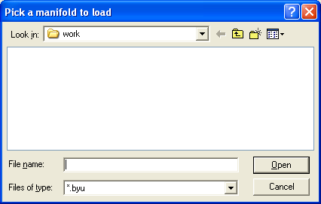
3 | Choose the type of file that you want to open using the drop down menu next to the Files of type label.
4 | Navigate to the location of the file you want to open and click Open.
5 | The manifold will now be displayed on the 3D view (assuming it is turned on). If the manifold does not show up, it is probably because its coordinate system is much smaller than the dataset’s and so cannot be seen.

Continued on next page
2-15

Opening a 2D manifold, Continued

Example | This is an example screen shot of the Short Data, with an apple:  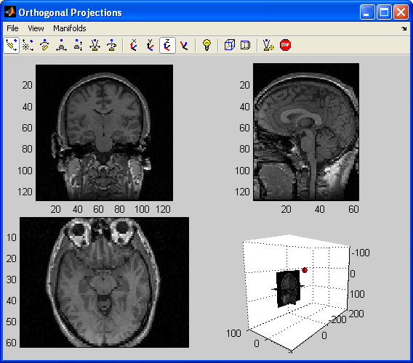

2-16

Navigating around the 3D view

Introduction | This section describes how to navigate around the 3D view using the camera toolbar.

IMPORTANT | Many of the other features described in this manual are dependent on the camera toolbar being turned off. When not navigating around the 3D view, make sure none of the six leftmost icons in the camera toolbar are highlighted.

Options | This table describes the parts of the camera toolbar and their function in order from left to right. The first seven of the following functions are invoked by highlighting the appropriate icon then holding down the mouse on the 3D view and dragging it. The last eight are simply clicked once.

Menu name | Function
Orbit camera | The camera follows the movement of the mouse around the currently selected principle axis.
Orbit scene light | The scene light follows the mouse.
Pan/tilt camera | The camera tilts to follow the movement of the mouse around the currently selected principle axis.
Move camera horiz./vert. | The whole axis moves to follow the mouse.
Move camera in/out | Moves the camera closer or farther away from the dataset.
Zoom camera | Zooms the camera in or out on the mouse position.
Roll camera | Rolls the camera around the clicked location.
X | Selects the x axis as the principle axis (used in conjunction with orbit and pan/tilt camera).
Y | Selects the y axis as the principle axis (used in conjunction with orbit and pan/tilt camera).
Z | Selects the z axis as the principle axis (used in conjunction with orbit and pan/tilt camera).
Toggle scene light | Toggles the scene light on and off.
Orthographic projection | Places the camera in an orthographic projection.
Perspective projection | Places the camera in a perspective projection.
Reset camera scene light | Puts the camera and lighting back to Matlab’s default 3D view.
Stop camera/light motion | When the camera or light are moving, this button will stop them.

2-17

Changing the appearance of 2D manifolds

Introduction | This section describes the seven options that are associated with all manifolds. This section assumes that you already have a visible manifold open.

Options | After opening a manifold, its name will appear under the Manifolds menu. There will also be a sub menu with the seven following options.

Menu Name | Function
Set Polygon Color | Brings up a color chooser dialog box (much like the one pictured under the cross hair section) and allows the user to select polygon colors.
Set Polygon Alpha | Brings up the following dialog box:  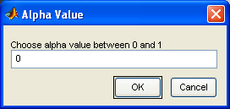  You then enter the alpha value you desire and hit OK.
Set Vertex Color | Brings up a color chooser dialog box (much like the one pictured under the cross hair section) and allows the user to select vertex colors.
Set Vertex Alpha | Brings up a dialog box much like the one pictured for Set Polygon Alpha and allows the user to enter the vertex alpha.
Set Edge On | Turns on edge highlighting.
Restore Defaults | Sets the manifold colors and alphas back to their defaults.
Close Manifold | Closes the manifold, and removes it from the 3D view

3-1

Landmarking

Overview

Introduction | This chapter describes how to use the landmark feature.

Prerequisites | This chapter assumes that you already have Mind View successfully installed on your machine, and that you have read the chapter on the basic viewer.

Getting started | In order to call the landmarking program type “landmarks” from the command prompt in Matlab. This will open a blank window just like the one described in starting the basic viewer. Then, open a dataset.

In this chapter | This chapter is divided into three sections.

Topic | See Page
Setting, deleting, and visiting a landmark | 3-2
Setting landmark options | 3-3
Exiting the GUI | 3-4

3-2

Setting, deleting, and visiting a landmark

Introduction | This section describes how to set, delete, and go to a landmark.

Procedure | Follow these steps to set a landmark.

Step | Action
1 | Go to Landmark → Set.
2 | Click on the point in one of the three 2D views that you want to set a landmark in.
3 | The following dialog box should come up:  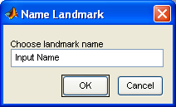  Input the name of the landmark that you just created.
4 | Click OK.
5 | The landmark will now appear as a circle on the three 2D images and the volume will be centered to that location.

Procedure | Follow these steps to go to a landmark.

Step | Action
1 | Click on Landmark.
2 | Mouse over Goto and then click on the landmark’s name.
3 | This landmark will now become the center of the view.

Procedure | Follow these steps to delete a landmark.

Step | Action
1 | Click on Landmark.
2 | Mouse over Delete and then click on the name of the landmark you wish to delete.
3 | The landmark will now no longer exist in the Goto or Delete lists and the circles representing it will no longer appear on the image.

3-3

Setting landmark options

Introduction | This section will describe all of the landmark options and how to change them.

Procedure | Follow these steps to toggle the circles on and off.

Step | Action
1 | Go to Landmark → Show Landmarks.
2 | This will cause this menu item to become unchecked on the circles will no longer be shown.
3 | Click the same menu item again and the check will reappear and so will the circles.

Procedure | Follow these steps to change landmark color.

Step | Action
1 | Go to Landmark → Set Landmark Color.
2 | A color picker dialog box will appear, looking like this:  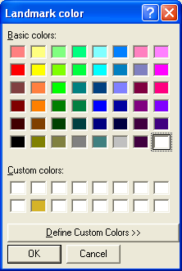
3 | Choose a new color for the landmarks and press OK.
4 | The landmarks will now be set to this color.

3-4

Exiting the GUI

Introduction | This section describes the exiting procedure.

Exiting the GUI | When you exit this GUI, the following dialog will appear:  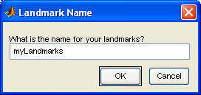  This allows you to give a name to the landmark structure in the base workspace of Matlab. The landmark structure stores all of the information concerning your landmarks. Pressing cancel causes them not to be stored.

4-1

Point Process

Overview

Introduction | This chapter describes how to do a point process on volume data.

Prerequisites | This chapter assumes that you already have Mind View successfully installed on your machine, and that you have read the chapter on the basic viewer.

Getting started | In order to call the point process program type “point” from the command prompt in Matlab. This will open a blank window just like the one described in starting the basic viewer. Then, open a dataset.

In this chapter | This chapter is divided into two sections.

Topic | See Page
Doing a point process | 4-2
Exiting the GUI | 4-3

4-2

Doing a point process

Introduction | This section gives instructions on how to perform a point process.

Procedure | Follow these steps to do a point process.

Step | Action
1 | Go to Point Processes.
2 | Mouse over the submenu that your point process is contained under.
3 | Click on the name of the point process that you wish to perform.
4 | Some of the point processes take a second argument (e.g. addition, raising to a power). In these cases, the following dialog box will appear:  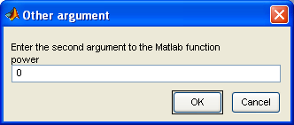
5 | From here, just enter the second argument and click OK.

4-3

Exiting the GUI

Introduction | This section describes the exiting procedure.

Exiting the GUI | When you exit the GUI, the following dialog box will appear:  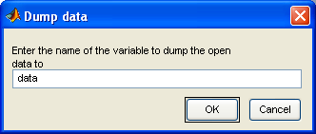  This box comes up because if you have done a point process then the data is modified. Enter a name for the modified dataset to be called in the base workspace and click OK. This will save the modified data to that name, and it can be read into any different GUI. It is in this way that you string together multiple actions across different GUI’s to the same dataset.  Clicking Cancel will cause the data not to be stored in the base workspace.

5-1

Neighborhood Process

Overview

Introduction | This chapter describes how to do a neighborhood process on a dataset.

Prerequisites | This chapter assumes that you already have Mind View successfully installed on your machine, and that you have read the chapter on the basic viewer.

Getting started | In order to call the neighborhood process program type “neighborhood” from the command prompt in Matlab. This will open a blank window just like the one described in starting the basic viewer. Then, open a dataset.

In this chapter | This chapter is divided into three sections.

Topic | See Page
Morphological neighborhood process | 5-2
Numerical neighborhood process | 5-3
Exiting the GUI | 5-4

5-2

Morphological neighborhood process

Introduction | This section describes how to do a morphological neighborhood process.

Procedure | Follow these steps to do a morphological neighborhood process.

Step | Action
1 | Go to Neighborhood Processes, then select the morphological neighborhood process that you wish to perform.
2 | The following dialog box will appear:  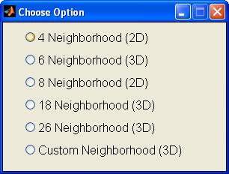  From here, select the neighborhood you wish.
3 | If you did not choose Custom Neighborhood, then you are done, if you did, then this next dialog box appears:  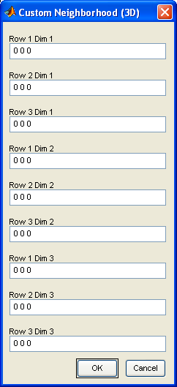  From here enter the values for the neighborhood that you wish to use by row and dimension, separated by spaces, then click OK.

5-3

Numerical neighborhood process

Introduction | This section describes how to do a numerical neighborhood process.

Procedure | Follow these steps to do a numerical neighborhood process.

Step | Action
1 | Go to Neighborhood then select the numeric point process you wish to perform.
2 | If you chose any option other than Median the following will appear:  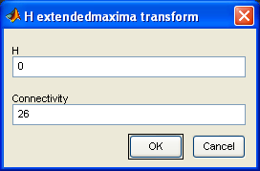  Where extendedmaxima will be replaced with the neighborhood process you selected. If you chose Median, the following will appear:  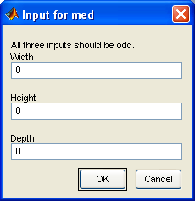
3 | In either case enter the appropriate values and press OK to see the transformation.

5-4

Exiting the GUI

Introduction | This section describes the exiting procedure.

Exiting the GUI | When you exit the GUI, the following dialog box will appear:  This box comes up because if you have done a neighborhood process then the data is modified. Enter a name for the modified dataset to be called in the base workspace and click OK. This will save the modified data to that name, and it can be read into any different GUI. It is in this way that you string together multiple actions across different GUI’s to the same dataset.  Clicking Cancel will cause the data not to be stored in the base workspace.

6-1

Combination Process

Overview

Introduction | This chapter provides information on doing processes involving more than one dataset.

Prerequisites | This chapter assumes that you already have Mind View successfully installed on your machine, and that you have read the chapter on the basic viewer.

Getting started | In order to call the combination process program type “combo” from the command prompt in Matlab. This will open a blank window just like the one described in starting the basic viewer. Since you are trying to do a combination process, open the second dataset that you want to do the combo process with.

In this chapter | This chapter is divided into two sections.

Topic | See Page
Doing a combo process | 6-2
Exiting the GUI | 6-3

6-2

Doing a combo process

Introduction | This section will outline the procedure to do a combo process.

Procedure | Follow these steps to do a combination process.

Step | Action
1 | Go to View and select the dataset that you wish to be the first input for the combo process.
2 | Go to Combo Process and click on the process that you wish to perform.
3 | A dialog box that looks like this will appear:  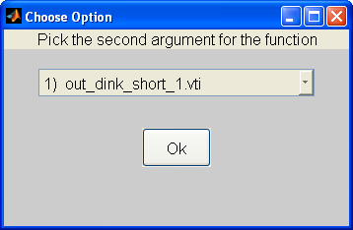  From the drop down menu select the second input for your combination process (the first input is the data that is currently open).
4 | Click OK and a new dataset will be opened which contains the result of what you chose to do.
5 | This will appear under the View menu as Answer to combo process, and it will automatically be selected.

6-3

Exiting the GUI

Introduction | This section describes the exiting procedure.

Exiting the GUI | When you exit the GUI, the following dialog box will appear:  This box comes up because if you have done a combo process then you have created a new dataset. Enter a name for the dataset to be called in the base workspace and click OK. This will save the currently viewed data to that name, and it can be read into any different GUI. It is in this way that you string together multiple actions across different GUI’s to the same dataset.  Clicking Cancel will cause the data not to be stored in the base workspace.

7-1

Interpolation Operations

Overview

Introduction | This chapter provides information on doing interpolation operations.

Prerequisites | This chapter assumes that you already have Mind View successfully installed on your machine, and that you have read the chapter on the basic viewer.

Getting started | In order to call the interpolation program type “interpolation” from the command prompt in Matlab. This will open a blank window just like the one described in starting the basic viewer. Then, open a dataset.

In this chapter | This chapter is divided into five sections.

Topic | See Page
Doing a rotation | 7-2
Extracting a portion of the volume | 7-3
General transformations | 7-4
Random rotations | 7-5
Exiting the GUI | 7-6

7-2

Doing a rotation

Introduction | This section gives the procedure for doing a rotation.

Procedure | Follow these steps to do a rotation.

Step | Action
1 | Go to Interpolation Operations → Set Rotation.
2 | The following dialog box will appear:  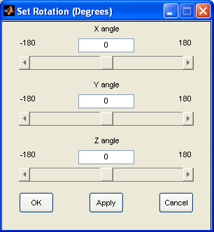  From here, set the x, y, and z angles for the volume to be rotated through. NOTE: These angles are in degrees.
3 | Click Apply to preview the result and OK to accept it.

7-3

Extracting a portion of the volume

Introduction | This section gives information on how to interpolate up a section of the data.

Procedure | Follow these steps to interpolate a specific portion of the volume.

Step | Action
1 | Move to the part of the dataset that you want to be the new center after the interpolation.
2 | Select Interpolation Operations → Extract Volume.
3 | The following dialog will appear:  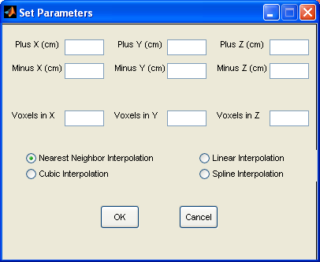  Enter in the appropriate values in each box. The first six boxes are in world coordinates and the other three boxes are the number of voxels after the interpolation.
4 | Choose your interpolation type and press OK. The new data will appear in the viewer.

7-4

General transformations

Introduction | This section outlines the steps to define your own transformation and send the data through that.

Procedure | Follow these steps to do a general projective transformation.

Step | Action
1 | Go to Interpolation Operations → General Transformation.
2 | A dialog box like this one will appear:  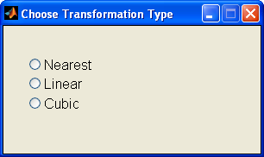  Choose the transformation type you wish to do.
3 | Then another dialog box will appear, and choose the boundary conditions:  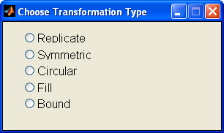
4 | Finally, a dialog box will appear allowing you to enter to transformation matrix:  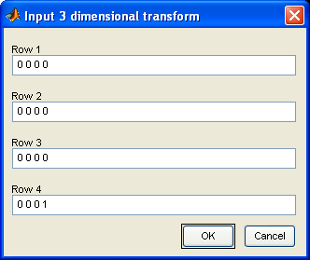  Enter each value per row, separated by spaces, then press OK.

7-5

Random rotations

Introduction | This section describes how to do a random rotation.

Procedure | Follow these steps to do a random rotation.

Step | Action
1 | Go to Interpolation Operations → Random Rotations.
2 | Choose the type of rotation that you wish to perform, either UIR for Uniform Independent Rotation or Random Vertical Rotation, by clicking on the appropriate name.

7-6

Exiting the GUI

Introduction | This section describes the exiting procedure.

Exiting the GUI | When you exit the GUI, the following dialog box will appear:  This box comes up because if you have done an interpolation operation then the data has been modified. Enter a name for the modified dataset to be called in the base workspace and click OK. This will save the modified data to that name, and it can be read into any different GUI. It is in this way that you string together multiple actions across different GUI’s to the same dataset.  Clicking Cancel will cause the data not to be stored in the base workspace.

8-1

Masks

Overview

Introduction | This chapter provides information on using masks.

Prerequisites | This chapter assumes that you already have Mind View successfully installed on your machine, and that you have read the chapter on the basic viewer.

Getting started | In order to call the mask program type “mask” from the command prompt in Matlab. This will open a blank window just like the one described in starting the basic viewer. Then, open a dataset.

In this chapter | This chapter is divided into three sections.

Topic | See Page
Drawing a new mask | 8-2
Editing a mask | 8-3
Exiting the GUI | 8-5

8-2

Drawing a new mask

Introduction | This section will give the procedure to draw a new mask.

Procedure | Follow these steps to draw a new mask.

Step | Action
1 | Go to Mask → Draw New Mask.
2 | Click on the 2D image that you wish to draw a mask on. This will cause your mouse to change to crosshairs.
3 | Once your mouse pointer becomes crosshairs, click on the point you wish to start drawing your mask.
4 | As you move to the next point in your mask, you will see a straight line that is draw from the first point you clicked, to the current mouse position.
5 | Click again to set the next mask point, and have that straight line be the mask boundary.
6 | Continue in this fashion until you have traced out the entire region on the mask.
7 | Double click or right click to create the last point in the mask.

Example | The following three screen shots show the construction of a mask.  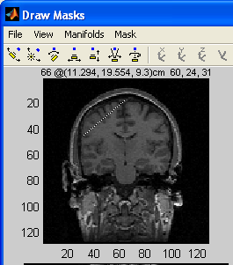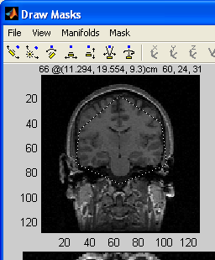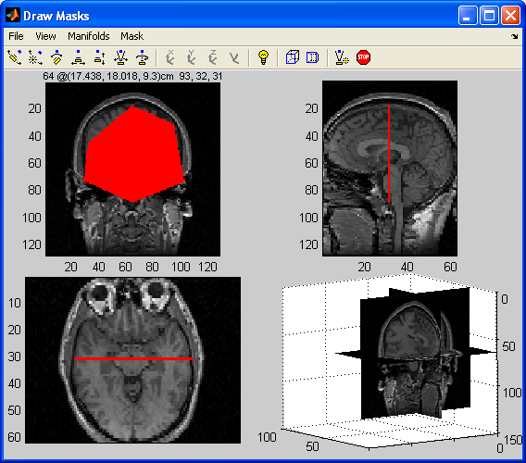

8-3

Editing a mask

Introduction | This section will describe all of the ways to edit a mask that is already drawn.

Procedure | Follow this procedure to add to a mask.

Step | Action
1 | Make sure Mask → Add to Mask has a check mark next to it, if it does not, then select it
2 | Go to Mask → Draw new Mask.
3 | Follow the same procedure as above. The resulting mask will be added to the current one.

Procedure | Follow this procedure to delete from a mask.

Step | Action
1 | Go to Mask → Delete from Mask.
2 | The check mark next to Add to Mask will change to Delete from Mask.
3 | Follow the instructions from the drawing a new mask section. The portion selected will be deleted from the mask.

Procedure | Follow these steps to change mask color.

Step | Action
1 | Go to Mask → Change Color.
2 | A color chooser dialog box will appear.
3 | Select the color you want the mask to be and click OK.

Continued on next page
8-4

Editing a mask, Continued

Procedure | Follow these steps to change mask alpha.

Step | Action
1 | Go to Mask → Change Alpha Value.
2 | A dialog box will come up like this one:  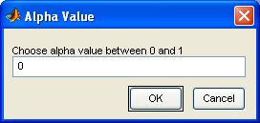  Enter a new alpha value and press OK.

Procedure | Follow these steps to toggle between mask boundaries and filled mask.

Step | Action
1 | Go to Mask → Mask Boundary.
2 | The check mark next to Fill Mask will change to Mask Boundary.
3 | The mask will now only be shown by an outline.
4 | Click on Mask → Fill Mask to go back to a filled mask.

Procedure | Follow these steps to get the volume of a mask.

Step | Action
1 | Go to Mask → Volume of Mask.
2 | In the command window will be printed the error in the x, y, and z directions along with the volume of the mask.

8-5

Exiting the GUI

Introduction | This section describes the exiting procedure.

Exiting the GUI | When you exit the GUI, the following dialog box will appear:  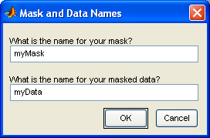  This box comes up because you have two things that you have modified. The first entry is for the name of the 3D logical array that represents your mask in the base workspace. The second entry is for the name of the data that is enclosed by your mask in the base workspace. When this data is read into another module, the part that was not selected by the mask is given a value of NaN. For instance, here is a screen shot of data that was masked, then read into orthogonal:  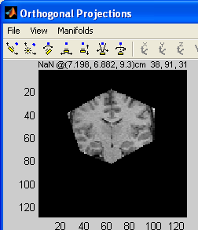  Pressing OK saves these variables to Matlab’s base workspace.

9-1

Volume Picker

Overview

Introduction | This chapter gives information on how to use the module that allows you to measure the volume of a space.

Prerequisites | This chapter assumes that you already have Mind View successfully installed on your machine, and that you have read the chapter on the basic viewer.

Getting Started | In order to call the volume picker program type “volumePicker” from the command prompt in Matlab. This will open a blank window just like the one described in starting the basic viewer.

In this chapter | This chapter is divided into three sections.

Topic | See Page
Opening a dataset | 9-2
Selecting and removing points | 9-3
Setting point options and finding volume | 9-5

9-2

Opening a dataset

Introduction | This section outlines the procedure for opening a dataset saved on your hard disk.

Procedure | Opening a new dataset.

Step | Action
1 | Follow the regular procedure described in basic viewer for opening a dataset.
2 | After you have selected the one you want, and pressed OK, the following dialog box will appear:  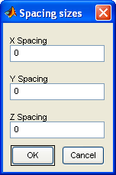
3 | Enter the values for the x, y, and z spacing in voxels and press OK.
4 | This will give a screen like this one (for this example I used 10, 10, and 6 for my spacing):  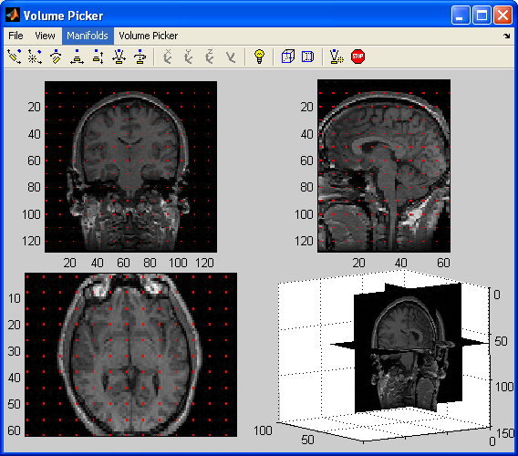

Note | In the volume picker module you will only be able to view slices that have points on them. This means that if you navigate to a different center the program will automatically choose the view closest to what you selected that has points on it.

9-3

Selecting and removing points

Introduction | This section describes how to designate points as “in” and “out.”

Procedure | Follow these steps to choose points that are “in” one at a time.

Step | Action
1 | Go to Volume Picker → Select in points.
2 | Click on any of the 2D views. The point nearest the position in which you clicked will change color to the current “in” color.
3 | Continue selecting points by clicking on them.
4 | Select Volume Picker → Select in points again, and the check mark will disappear, and you will no longer be in point picking mode.

Procedure | Follow these steps to remove “in” points.

Step | Action
1 | Go to Volume Picker → Remove in points.
2 | Now, when you click on any point that is already “in” it will change color back to its original color.
3 | Continue removing points by clicking on them.
4 | Select Volume Picker → Remove in points again, and the check mark will disappear, and you will no longer by in point removing mode.

Continued on next page
9-4

Selecting and removing points, Continued

Procedure | Follow these steps to select many points all at once.

Step | Action
1 | Go to Volume Picker → Select many points.
2 | Click on the 2D view in which you want to select many points.
3 | The cursor will now change to a cross hair, and you will follow the same procedure as described in adding a new mask. Keep clicking to surround the points that you want to be in, and double or right click to signify the end of your polygon.
4 | All of the points inside of the polygon will change color to the “in” color.

Note | There is no way to designate a group of points as being “out,” you must do this one point at a time.

9-5

Setting point options and finding volume

Introduction | This section will describe how to change all of the options associated with the points, and how to find the volume.

Procedure | Follow these steps to toggle the points on and off.

Step | Action
1 | Go to Volume Picker → Show Points.
2 | When clicked, the check mark will go away and so will the points.
3 | Click the same menu item to turn the points back on.

Procedure | Follow these steps to change the point colors.

Step | Action
1 | Go to Volume Picker → Choose point color.
2 | A color picker dialog box will appear asking for a new point color. This is the color associated with points that have not been selected. Choose the color you wish, and then press OK.
3 | Another color picker dialog box will appear. This is the color associated with points that have been selected. Choose the color you wish, and then press OK.

Procedure | Finding the volume of the currently selected points.

Step | Action
1 | Go to Volume Picker → Find volume.
2 | In the Matlab command window, the x, y, and z error will appear along with the volume.

10-1

Surface Area

Overview

Introduction | This chapter gives information on measuring the surface area using a uniform independent rotation (UIR).

Prerequisites | This chapter assumes that you already have Mind View successfully installed on your machine, you have read the chapter on the basic viewer, and have read the section on random rotations under the chapter on interpolation operations.

Getting Started | In order to get an accurate measurement, the dataset must undergo a UIR. Do this first, then save the data to the base workspace. Now make the following call “surfaceArea(<name of data>)” where <name of data> is replaced by what was saved out from the interpolation call. This will bring up the following dialog box:  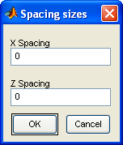  Enter the x and z spacing in voxels that you desire and press OK.

In this chapter | This chapter is divided into two sections.

Topic | See Page
Selecting and removing points | 10-2
Setting options and finding surface area | 10-3

10-2

Selecting and removing points

Introduction | This section describes the procedure to select a point on a line and to remove a point on a line.

Procedure | Follow these steps to select points.

Step | Action
1 | Go to Surface Area → Select points.
2 | Click on any of the 2D views and the point selected will be on the line closest to where you clicked. This point will change to a new color.
3 | Click on Surface Area → Select points to remove the checkmark next to it and take you out of selection mode.

Procedure | Follow these steps to remove points.

Step | Action
1 | Go to Surface Area → Remove points.
2 | Click on any of the 2D views and the point removed will be on the line closest to where you clicked. This point will change back to its original color.
3 | Click on Surface Area → Remove points to remove the checkmark next to it and take you out of removal mode.

Note | In the surface area module you will only be able to view slices that have lines on them. This means that if you navigate to a different center the program will automatically choose the view closest to what you selected that has lines on it.

10-3

Setting options and finding surface area

Introduction | This section describes how to set various options and compute the surface area.

Procedure | Follow these steps to toggle the lines on and off.

Step | Action
1 | Go to Surface Area → Show Lines.
2 | Once clicked, the checkmark next to this menu item and the lines on the 2D views will disappear.
3 | Click on the same menu item to make the lines reappear.

Procedure | Follow these steps to change the base and selected colors.

Step | Action
1 | Go to Surface Area → Choose line and point color.
2 | A color chooser dialog box will come up asking for a new line color. Choose the color that you wish and press OK.
3 | Another color chooser dialog box will appear asking for a new point color. This is the selected color. Choose a new color then press OK.

Procedure | Finding the surface area using the selected points.

Step | Action
1 | Go to Surface Area → Find surface area.
2 | The surface area will be printed in the command window.

11-1

Surface Area using Cycloids

Overview

Introduction | This section contains information on finding surface area using a random vertical rotation and cycloids.

Prerequisites | This chapter assumes that you already have Mind View successfully installed on your machine, you have read the chapter on the basic viewer, and have read the section on random rotations under the chapter on interpolation operations.

Getting started | In order to get an accurate measurement, the dataset must undergo a random vertical rotation. Do this first, and then save the data to the base workspace. Now make the following call “cycloidSA(<name of data>)” where <name of data> is replaced by what was saved out from the interpolation call. This will bring up the following dialog box:  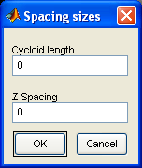  Enter the cycloid length and z spacing in voxels that you desire and press OK.

In this chapter | This chapter is divided into two sections.

Topic | See Page
Selecting and removing points | 11-2
Setting options and finding surface area | 11-3

11-2

Selecting and removing points

Introduction | This section describes how to select and remove points.

Procedure | Follow these steps to select points.

Step | Action
1 | Go to Surface Area → Select points.
2 | Since only the coronal view has cycloids on it, this is the only view in which points can be selected. Click on a point in the coronal view and the point on the cycloid closest to where you clicked will change to a new color.
3 | Click on Surface Area → Select points to remove the checkmark next to it and take you out of selection mode.

Procedure | Follow these steps to remove selected points.

Step | Action
1 | Go to Surface Area → Remove points.
2 | Click in the coronal view on the point you wish to be removed. This point will no longer be colored.
3 | Click on Surface Area → Remove points to remove the checkmark next to it and take you out of removal mode.

Note | In the cycloid surface area module you will only be able to view slices that have cycloids on them. This means that if you navigate to a different center the program will automatically choose the view closest to what you selected that has lines on it.

11-3

Setting options and finding surface area

Introduction | This section describes how to change various options, and how to find the surface area.

Procedure | Follow these steps to toggle the cycloids on and off.

Step | Action
1 | Go to Surface Area → Show Lines.
2 | Once clicked, the checkmark next to this menu item and the cycloids on the coronal view will disappear.
3 | Click on the same menu item to make the cycloids reappear.

Procedure | Follow these steps to change the cycloid and selected color.

Step | Action
1 | Go to Surface Area → Choose line and point color.
2 | A color chooser dialog box will come up asking for a new cycloid color. Choose the color that you wish and press OK.
3 | Another color chooser dialog box will appear asking for a new point color. This is the selected color. Choose a new color then press OK.

Procedure | Follow these steps to find the surface area using the points clicked.

Step | Action
1 | Go to Surface Area → Find surface area.
2 | The surface area will be printed in the command window.

12-1

Cell Counter

Overview

Introduction | This chapter gives details on using the cell counter feature.

Prerequisites | This chapter assumes that you already have Mind View successfully installed on your machine, and that you have read the chapter on the basic viewer.

Getting started | In order to call the cell counter program type “cellCounter” from the command prompt in Matlab. This will open a blank window just like the one described in starting the basic viewer.

In this chapter | This chapter is divided into three sections.

Topic | See Page
Opening a dataset | 12-2
Selecting and removing points | 12-3
Setting options and finding the number of objects | 12-4

12-2

Opening a dataset

Introduction | This section outlines how to open a new dataset.

Procedure | Follow these steps to open a new dataset.

Step | Action
1 | Follow the regular procedure described in the basic viewer for opening a dataset.
2 | After selecting the dataset you want, the following dialog box will appear:  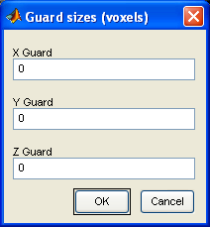
3 | Enter the size of the guard that is appropriate for your purposes, in voxels, then press OK.
4 | After doing this, a screen like this one will appear, I used 30, 30, 10 for my guard:  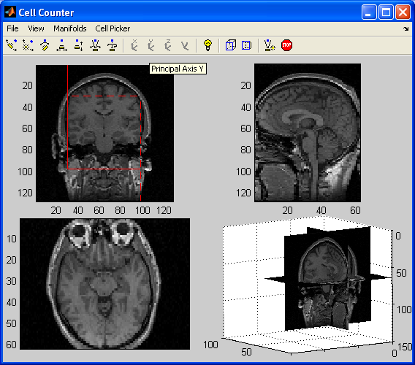

Note | In the cell counter module you will only be able to view slices that are within the specified guard. This means that if you navigate to a center outside of the guard, the program will automatically choose the view closest to what you selected that has is inside the guard.

12-3

Selecting and removing points

Introduction | This section will describe how to select and remove points.

Procedure | Follow these steps to select a point.

Step | Action
1 | Go to Cell Picker → Select in points.
2 | Since the coronal view is the only one with the guard on it, any click in that view will select a point. That point’s color will change.
3 | Only points that are to the right and above the solid line, and to the left and below the dashed line can be selected. Points on the dashed line can be selected (with the exception of the part below the square) but points on the solid line cannot.
4 | Continue clicking points to select more.
5 | Click on the same menu item to remove the checkmark, and take the mouse out of point picking mode.

Procedure | Follow these steps to remove a point.

Step | Action
1 | Go to Cell Picker → Remove in points.
2 | Click on any point that has already been selected (is of a different color) to unselect it. The color on it will go away.
3 | Continue to remove points in a similar fashion.
4 | Click on the same menu item to remove the checkmark, and take the mouse out of point removing mode.

12-4

Setting options and finding the number of objects

Introduction | This section will describe how to change the options associated with the cell counter, and how to find the number of objects selected.

Procedure | Follow these steps to toggle the guard and points on and off.

Step | Action
1 | Go to Cell Picker → Show points.
2 | The guard and the selected points will disappear.
3 | Click on this menu item again to make the checkmark return, along with the guard and points.

Procedure | Follow these steps to choose a new guard and point color.

Step | Action
1 | Click on Cell Picker → Choose point color.
2 | A color chooser dialog box will appear asking for you to select a new point color.
3 | Choose the color that you want for the points and click OK.
4 | Another color chooser dialog box will appear asking for a new line color. This is the color of the guard.
5 | Choose the color that you want for the guard and click OK.

Procedure | Follow these steps to get the number of objects.

Step | Action
1 | Go to Cell Picker → Find number of cells.
2 | This will cause the number of objects selected and the density to be printed out in the command window.

13-1

Talairach Functions

Overview

Introduction | This section gives detailed information on how to use the features associated with the Talairach altas.

Prerequisites | This chapter assumes that you already have Mind View successfully installed on your machine that you have read the chapter on the basic viewer that you have read the chapter on landmarks, and that you have read the chapter on masks.

Getting Started | In order to call the Talairach program type “talairach(myData, myMask)” from the command prompt in Matlab. myData has to be data that was loaded into the workspace and myMask is a mask of the data that is outputted from mask command. The mask should be of just the brain.

In this chapter | This chapter is divided into five sections

Topic | See Page
Setting the AC, PC, and Midline points | 13-2
Finding locations in Talairach space | 13-3
Setting options associated with the Talairach atlas | 13-5
Exiting the GUI | 13-7

13-2

Setting the AC, PC, and Midline Points

Introduction | This section will describe how to correctly set the AC, PC, and Midline points

Procedure | Follow these steps to set the AC point

Step | Action
1 | Navigate around the dataset until the desired position of the AC point is at the center of the screen. (Turning on crosshairs may help with this process.)
2 | Go to Landmark → Set
3 | Click on the point where the AC point is desired.
4 | When naming the landmark, make sure to name it AC (this is case sensitive).

Procedure | In order to set the PC and Midline points follow the same steps above. Name the PC point PC and the Midline point MIDLINE.

Note | In order to get the Talairach functions to work with mult-time data, the AC, PC, and Midline points must be set on ALL time slices.

13-3

Finding locations in Talairach space

Introduction | This section will discuss the two ways to navigate around the dataset using Talairach information.

Procedure | Follow these steps to set the x, y, and z coordinates in Talairach centimeters.

Step | Action
1 | Go to Talairach → Set Talairach Coordinates and the following dialog should pop up:  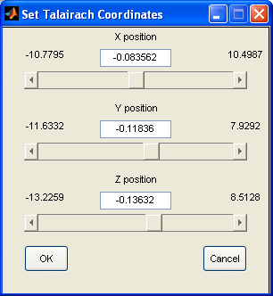
2 | Use the sliders or enter in values in the text boxes to set the new viewing center in Talairach centimeters.
3 | Press OK to go there and close the dialog.

Continued on next page

13-4
Finding locations in Talairach space, Continued

Procedure | Follow these steps to set current Talairach box coordinates.

Step | Action
1 | Go to Talairach → Set Talairach labels and the following dialog should pop up:  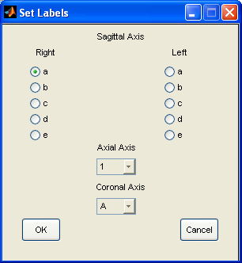
2 | Use the radio buttons the select the left or right side (a-e).
3 | Use the first drop down menu to select the axial box location (1-12)
4 | Use the second drop down menu to select the coronal box location (A-J,Z)
5 | Press OK to go to the center of that box and close the dialog.

13-5

Setting options associated with the Talairach atlas

Introduction | This section will go over how to change the location of the mouse, how to change the orientation of the brain, how to get information on the current center of the view and how to highlight regions.

Procedure | Follow these steps to change the display of the coordinates from value@(x, y, z) world coordinates x, y, z, time, channel voxel coordinates to value@(x, y, z) talairach coordinates x, y, z, time, channel voxel coordinates.

Step | Action
1 | Go to Talairach → Change Coordinate System → Talairach Coordinates.
2 | Now mouse over one of the three 2D views and notice how the location is displayed in Talairach coordinates.
3 | Go to Talairach → Change Coordinate System → World Coordinates to switch back to the original system.

Procedure | Follow these steps the change the orientation of the brain.

Step | Action
1 | Go to Talairach → Orientation of Brain → Talairach Orientation.
2 | The brain will now have rotated into Talairach orientation so that the AC and PC points lie on the z axis and the Midline points up.
3 | Go to Talairach → Orientation of Brain → Original Orientation to switch it back.

Continued on next page

13-6
Setting options associated with the Talairach atlas, Continued

Procedure | To get information about the current center of the view go to Talairach → Get Info For Current Location and the following submenu will appear.

Part | Function
Talairach Coordinates | Displays the current location in Talairach coordinates.
Box Coordinates | Displays the current box coordinates.
Talairach Labels | Displays the current Talairach label coordinates (r, l a-e, 1-12, A-J).
Side Region | Displays which area on the side labeled brain is at the center.
Lobe Region | Displays which area on the lobe labeled brain is at the center.
Area Region | Displays which area on the area labeled brain is at the center.
Type Region | Displays which area on the type labeled brain is at the center.
Brodman Area Region | Displays which area on the Brodman labeled brain is at the center.
Complete Coordinate Description | Displays all of the above information at once.

Notes | - This information is more easily viewed with the crosshairs on.  - The results are displayed in the Command Window.  - For a complete list of which areas are in which brains see the highlighting section.

Procedure | Follow these steps to highlight regions of the brain.

Step | Action
1 | Go to Talairach → Highlight Structure.
2 | Select the type of area that is desired and mouse over it.
3 | A list of all of the structures in that area will appear. Click on the desired one.
4 | To change the color go to Talairach → Highlight Structure → Options → Set Color and a color chooser dialog will appear.
5 | To change the alpha go to Talairach → Highlight Structure → Options → Set Alpha and an alpha chooser dialog will appear.
6 | To turn the highlighting off go to Talairach → Highlight Structure → Off

13-7

Exiting the GUI

Introduction | This section will describe exiting procedures.

Exiting the GUI | When the GUI is exited, the same dialog box that appeared when exiting the Landmarks module will appear. Choose a name for the landmarks or click cancel. If there is currently no highlight on then a second dialog box looking like this will appear:  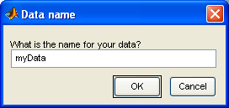  This allows for assigning the data to the base workspace. This is most useful if the rotated data is desired.  If a highlight is currently on then the following dialog will appear:  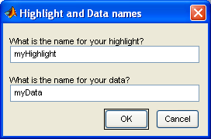  This dialog will assign the highlight and the data to the base workspace in the same format as closing the mask dialog box does.

